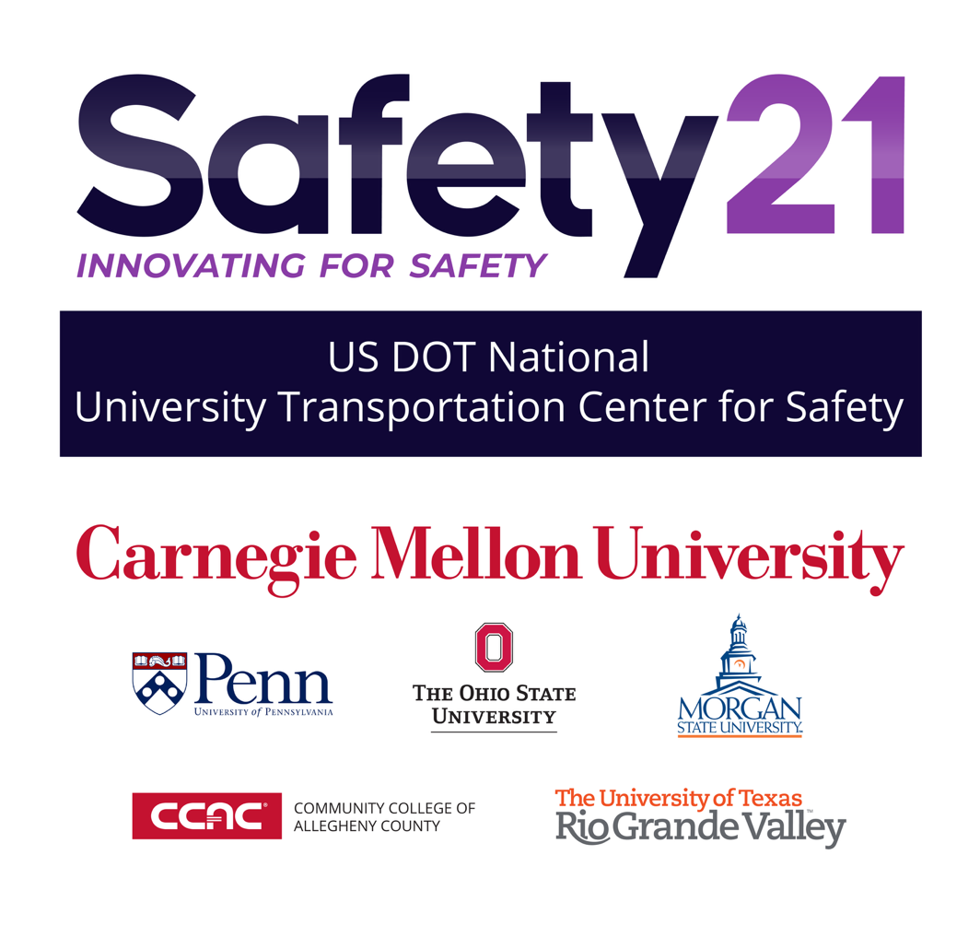

Using Autonomous Vehicle Technologies to Improve Workforce Development in Manufacturing, Supply Chain, and EV Repair

Justin Starr, ORCID 0000-0003-0173-7402
Robert Koch, Co-PI

Final Report - September 4, 2026

DISCLAIMER
The contents of this report reflect the views of the authors, who are responsible for the facts and the accuracy of the information presented herein. This document is disseminated in the interest of information exchange. The report is funded, partially or entirely, under [grant number 69A3552344811 / 69A3552348316] from the U.S. Department of Transportation’s University Transportation Centers Program. The U.S. Government assumes no liability for the contents or use thereof.

Safety21
Community College of Allegheny County
Annual Report 2025-2026
Project Overview
During the 2025-2026 program year, the Community College of Allegheny County (CCAC) continued a multi-year Safety21 workforce development effort connecting emerging transportation technologies with technician education. Project #641 built on prior work in electric vehicles, autonomous systems, artificial intelligence, and spaceflight-related supply chain education. The project was organized around a common goal: helping students in automotive, mechatronics, and advanced manufacturing programs understand technologies that are increasingly part of the environments in which technicians work. The project also continued CCAC's emphasis on apprenticeship and pre-apprenticeship as practical mechanisms for moving new technical content from the classroom into the regional workforce.
Autonomous Systems Safety and AI Literacy for Manufacturing Technicians
A major emphasis of Project #641 was translating concepts normally associated with autonomous vehicles into manufacturing and mechatronics education. Modern manufacturing technicians increasingly work around autonomous mobile robots, machine vision, lidar, radar, and computer-controlled material handling systems. The project therefore focused on introducing students to how autonomous systems perceive their surroundings, make navigation decisions, and respond to changing conditions, while connecting those concepts to safe work practices around industrial automation.
This work extended earlier CCAC research showing that students make safer programming decisions when autonomy is taught as a graded concept rather than as a simple distinction between manual and autonomous operation. During the project period, CCAC continued integrating AI and autonomy into technician education and apprenticeship activities. At the 2025 Safety21 Deployment Partner Consortium Symposium, CCAC presented its work on AI education for transportation technicians and reported early results showing marked improvement in AI literacy among apprenticeship students. The approach intentionally used examples that do not require an advanced mathematics or computer science background, allowing AI and autonomy to function as practical technical-literacy topics for skilled-trades students.
EV Technician Apprenticeship and Pre-Apprenticeship Pipeline
Project #641 also continued expansion of CCAC's registered Electric Vehicle Automotive Technician Apprenticeship, developed with the German American Chamber of Commerce (GACC) Pittsburgh Chapter, regional automotive employers, and workforce partners. The apprenticeship uses a vendor-agnostic model rooted in the German dual system and combines technical instruction with paid on-the-job learning. By the 2025-2026 period, two cohorts were underway, with 25 participants receiving hands-on preparation for electric vehicle service and repair.
The next phase of the work focused on extending the pathway into secondary education. CCAC and its partners worked with regional Career and Technology Centers (CTCs) to adapt high-voltage safety, electric vehicle systems, and related advanced driver assistance concepts for students in Grades 9-12. This work is intended to create a clearer transition from automotive programs at CTCs into registered apprenticeship while allowing students to begin developing high-voltage awareness and safety competencies before entering the workplace. Regional workforce partners have separately documented work with CTCs, including Parkway West CTC and Steel Center for Career and Technical Education, to develop secondary-level EV curriculum suitable for pre-apprenticeship registration.
Student Spaceflight Experiments and Supply Chain STEM Outreach
CCAC continued to use the Student Spaceflight Experiments Program (SSEP) as a way to connect technical education with the constraints of transportation, logistics, and operations beyond Earth. As in earlier Safety21 projects, students were encouraged to develop experiment concepts and participate in a structured review process that requires them to consider payload limitations, scheduling, materials, transport, and the consequences of delays or failures in a tightly constrained supply chain.
The broader SSEP effort also continued to connect CCAC students with regional K-12 and CTC students. In March 2026, CCAC recognized students from Parkway West CTC whose mission-patch designs had traveled to space as part of the program. These activities provide an accessible entry point for younger students while reinforcing the project’s larger workforce-development theme: transportation and supply chain systems increasingly depend on technicians who can work across traditional disciplinary boundaries.
Dissemination and Workforce Impact
The project emphasized dissemination through workforce partners and public-facing education activities rather than treating the work as a stand-alone research exercise. CCAC continued to share its apprenticeship, AI-literacy, and emerging-technology education models with Safety21 partners and regional employers. The project also reinforced the College's broader strategy of making advanced technology understandable and usable for technicians who may not identify as programmers or engineers but who will routinely work beside intelligent machines, electric-drive systems, and connected equipment.
Taken together, Project #641 demonstrates a practical model for technician workforce development in which autonomous vehicle concepts can be repurposed to improve manufacturing safety education, high-voltage training can create a bridge from secondary automotive programs into registered apprenticeship, and spaceflight activities can make supply chain constraints tangible to students. The work continues CCAC's focus on open, transferable educational approaches that other two-year colleges and workforce providers can adapt without needing to create an entirely new technical program.
Conclusion
Safety21 support allowed CCAC to continue building a connected set of workforce pathways around autonomy, electric vehicles, artificial intelligence, and transportation-related supply chain concepts. The strongest result of the multi-year effort is the integration of these topics into existing technician education and apprenticeship structures rather than creation of isolated specialty courses. This approach gives students repeated exposure to emerging technologies in contexts that are directly connected to employment and provides employers with a practical mechanism for upskilling both new entrants and incumbent workers.
Technical Report Documentation Page
1. Report No.  Safety21 Project #641 | 2. Government Accession No. |  |  | 3. Recipient’s Catalog No.
4. Title and Subtitle  Using Autonomous Vehicle Technologies to Improve Workforce Development in Manufacturing, Supply Chain, and EV Repair |  |  |  | 5. Report Date  September 4, 2026
6. Performing Organization Code
N/A
7. Author(s)  Justin Starr, https://orcid.org/0000-0003-0173-7402  Robert Koch |  |  |  | 8. Performing Organization Report No.  N/A
9. Performing Organization Name and Address  Community College of Allegheny County  808 Ridge Avenue  Pittsburgh, PA 15212 |  |  |  | 10. Work Unit No.  N/A
11. Contract or Grant No.
Federal Grant # 69A3552344811 / 69A3552348316
12. Sponsoring Agency Name and Address  Safety21 University Transportation Center  Carnegie Mellon University  5000 Forbes Avenue  Pittsburgh, PA 15213 |  |  |  | 13. Type of Report and Period Covered  Final Report (July 1, 2025 - June 30, 2026)
14. Sponsoring Agency Code
USDOT
15. Supplementary Notes
Conducted in cooperation with the U.S. Department of Transportation, Federal Highway Administration.
16. Abstract
This project extended prior Safety21 workforce-development work by advancing three related technician-education pathways: autonomous-systems safety and AI literacy in manufacturing education; EV apprenticeship and pre-apprenticeship development; and student engagement in transportation and supply-chain STEM activities through SSEP. During the period, CCAC continued its registered Electric Vehicle Automotive Technician Apprenticeship, which expanded to two cohorts totaling 25 participants, and worked with regional Career and Technology Centers to develop a secondary-level pathway into EV apprenticeship. CCAC also continued SSEP outreach with regional secondary students and disseminated AI education work for transportation technicians, reporting early improvement in AI literacy among apprenticeship students. The project demonstrates how autonomy, high-voltage safety, apprenticeship, and hands-on STEM activities can be integrated into existing technician programs to prepare students for workplaces increasingly shaped by intelligent and electrified systems.
17. Key Words  Workforce Development; Autonomous Vehicles; Electric Vehicles; Apprenticeship; Artificial Intelligence; Manufacturing Safety; Supply Chain |  |  | 18. Distribution Statement  No restrictions. This document is available through the National Technical Information Service, Springfield, VA 22161.
19. Security Classif. (of this report)  Unclassified |  | 20. Security Classif. (of this page)  Unclassified |  |  | 21. No. of Pages  5 | 22. Price  N/A
Form DOT F 1700.7 (8-72) |  | Reproduction of completed page authorized

