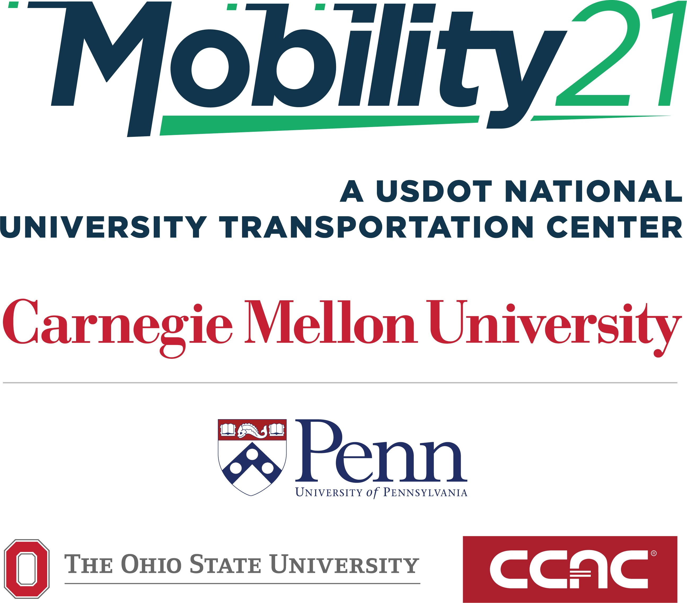

Towards Data-Driven and Continuous Safety Inspection of Commercial Trucks and Trailers

Principal Investigator: Pingbo Tang
(ORCID: 0000-0002-4910-1326)
The contents of this report reflect the views of the authors, who are responsible for the facts and the accuracy of the information presented herein. This document is disseminated under the sponsorship of the U.S. Department of Transportation’s University Transportation Centers Program, in the interest of information exchange. The U.S. Government assumes no liability for the contents or use thereof.
FINAL RESEARCH REPORT
Contract #373

DISCLAIMER

Accomplishments

What are the major goals and objectives of the project?
The overall goal is to enable predictive management of commercial vehicle fleets (tractors and trailers) for balancing safety, operating cost, and workforce performance through both real-time and historical inspection data analytics of commercial vehicle fleets.
- Build a data analytics architecture to hold commercial vehicle tractor and trailer inspection data.
- Tie real-time data to the database connecting sensory information by use of telematics.
- Enable automatic prioritization of vehicles and their safety-critical components that need preventive inspection and maintenance based on real-time telematics and historical inspection data.
- Quantify the value of using real-time sensor data for automatic inspection to justify automatic inspection results and identify policy implications of using telematics in practice.

What was accomplished under these goals?
Since July 2021, the project team has focused on analyzing multiple vehicle inspection data. We have developed a vehicle data analytics and visualization dashboard for analyzing deterioration rates of vehicles and predicting the percentages of high-risk vehicles of a given commercial vehicle fleet based on historical deterioration rates of various vehicles, as indicated in the inspection data.
- Conducted extensive search of various data sources that show the results of inspecting tractors and trailers.
- Collected inspection manuals and data and observed inspection processes through collaboration with Compuspections (an industry collaborator and deployment partner of the project).
- Collected FMCSA data for monitoring performance of motor carriers and historical vehicle inspection data accumulated by Compuspections. We are in the process of acquiring vehicle emission inspection and registration data from PennDOT.
- Collected some real-time sensor data generated by typical Telematics systems deployed by Clarience Technologies (an industry collaborator and deployment partner of the project) for the integrated analysis of historical inspection data and real-time sensor data for monitoring vehicle performance
- Developed algorithms for matching the records from the inspection data collected by Compuspections and the records from FMCSA data sources and generating statistical analysis results to show how the historical inspection data capture the factors that influence the failure rates of various components of tractors and trailers
- Developed supervised machine learning algorithms (decision trees and random forests) for automatically identifying critical vehicle attributes for predicting the failures of passing the inspection, the inspection cost, and inspection time
- Developed unsupervised machine learning algorithms (clustering) for automatically grouping vehicles with similar properties and failure modes together and predicting the failure modes of a given vehicle based on the similarity between it and the frequent failure modes of vehicles in the same cluster with it.
- Developed a data-driven Monte-Carlo simulation model that derives the deterioration rates of the brake pads and tire tread depths based on all inspection reports of various vehicles. We used these Monte-Carlo simulation models to simulate the deteriorations of a given commercial vehicle fleet with the current tire and brake states for predicting the percentage of vehicles that will fail the brake and tire inspections within a year.
- Developed text analysis and natural language processing algorithms that can automatically organize the inspection reports’ descriptions of vehicles’ conditions into tables to enable more detailed analysis of inspection reports.
- Started approaching motor carriers, such as Pitt-Ohio, to show the capabilities of the developed algorithms in predicting the failure rates of safety-critical components (brake, door, tire, light) of a given vehicle fleet and helping with the identification of high-risk vehicles. We will schedule a meeting in Fall 2022 with Pitt-Ohio to present how our approach help with identifying vehicles having attributes highly relevant to risky vehicle failure modes.
- Used the data analytics architecture to identify critical vehicle components and justify the real-time sensor data collection for monitoring those components using Telematics systems. We use the simulation results to show how continuous monitoring of critical components could reduce crash rates, maintenance costs, and mobility of a given commercial vehicle fleet.
- Examined commercial vehicle fleets’ safety-efficiency tradeoffs by analyzing historical inspection records of multiple commercial motor carriers. Two algorithms, K-means clustering, and Latent Dirichlet Allocation, collectively analyzed different temporal-spatial failure modes among vehicles and carriers. The identified component failure modes could prioritize inspection and maintenance plans for inspectors, drivers, and fleet managers, which help avoid repetitive out-of-service violations and improve fleet operational strategies with less mobility reduction.

Outcomes
The project team has produced the following outcomes as the application of outputs:
- Increases in the knowledge about the deterioration and failure rates of various components of tractors and trailers - which has limited deterioration models reported in the literature
- Improved processes of linking commercial vehicle inspection databases for enabling multi-data source-based queries that ask about the performance of vehicles under different conditions and deterioration rates of various vehicle components
- Trained the industry professionals in analyzing and processing multiple vehicle inspection data sources
- Educated the industry professionals about the potential benefits of targeted continuous monitoring of critical vehicle components through telematics techniques
- Trained three Ph.D. students in comprehending the practical problems of commercial vehicle fleet performance monitoring and predictive fleet management based on automatic data analytics and real-time telematics data
- Formed a basis for quantifying the benefits of using Telematics technologies in practice by revealing critical vehicle components that need more detailed and frequent inspections due to deterioration rates faster than the assumptions of the current practice
- Generated an interface for historical data visualization, analysis, and information and knowledge query, which can help fleet managers learn management experience and suggest operation actions

What opportunities for training and professional development has the project provided?
- Three Ph.D. students (Chenyu Yuan, Ruoxin Xiong, Ying Shi) in the Department of Civil and Environmental Engineering have learned the practice of commercial vehicle fleet inspection and maintenance planning, accumulating data analysis results for future presentations and research publications.
- The three Ph.D. students (Chenyu Yuan, Ruoxin Xiong, and Ying Shi) have weekly meetings with industry collaborators to develop their skills in presenting the work to industry professionals and identifying scientific problems from practical problems. They also get feedback from the industry professionals about various data quality issues in the inspection data and have developed new scientific methods for vehicle inspection data analysis and predictive fleet management
- One M.S. Student (Jiayi Li) in the Department of Civil and Environmental Engineering has gotten the opportunity to work with the project team in developing a dashboard that visualizes the deterioration trends and recommendations for inspection and maintenance plans for given vehicles based on historical inspection reports.
- One Ph.D. student (Chenyu Yuan) presented the research work overview at the Mobility Symposium in October 2021
- One Ph.D. student (Chenyu Yuan) presented the research work on “Clustering Heavy Duty Truck Failure Modes for Proactive Safety Inspection and Efficient Operations of Commercial Vehicle Fleets” at the 7th Annual UTC Conference for the Southeastern Region in Boca Raton, FL, March 2022

How have the results been disseminated? If so, in what way/s?
- The most frequent distribution of the results is through weekly meetings with industry professionals to show them the results of data collection and analysis for supporting predictive commercial vehicle fleet management.
- For the 2022 Summer Engineering Experience (SEE) program, PI Tang presented his work related to airport management and vehicle management. He also provided students with an opportunity to engage in an advanced infrastructure lab activity with bridges and an air traffic control presentation.
- PI Tang presented the project’s results at PITA Industry Board Meeting (featured speaker) on June 2nd. The title of the presentation was “Towards Data-Driven and Continuous Safety Inspection of Commercial Trucks and Trailers.”
- One Ph.D. student (Chenyu Yuan) presented the research work overview at the Mobility Symposium in October 2021
- One Ph.D. student (Chenyu Yuan) presented the research work on “Clustering Heavy Duty Truck Failure Modes for Proactive Safety Inspection and Efficient Operations of Commercial Vehicle Fleets” at the 7th Annual UTC Conference for the Southeastern Region in Boca Raton, FL, March 2022
- Three Ph.D. students (Chenyu Yuan, Ying Shi, and Ruoxin Xiong) have submitted a manuscript to the Journal of Transportation Research Record (TRR) to report their work on “Identifying Safety-Critical Heavy-duty Vehicles in Fleets with Complementary Vehicle Inspection Datasets through Cross-Database Clustering Analysis.”
- One M.S. student (Jiayi Li) presented at the Summer Research Symposium of the Civil and Environmental Engineering Department. The short presentation is on the truck fleet management dashboard for visualizing truck fleet deterioration rates based on historical inspection reports.
- The project team is in the process of developing a journal manuscript for submission around October 2022.
- The project team developed a website: TrSafety - Towards Data-Driven and Continuous Safety Inspection of Commercial Trucks and Trailers (https://sites.google.com/andrew.cmu.edu/trsafety/home)

Products

Publications, conference papers, and presentations
- Journal manuscripts published
- Journal manuscripts accepted
- Journal manuscripts in review or in preparation
  - Yuan, C., Shi, Y., Xiong, R., & Tang, P*, (under review) “Identifying Safety-Critical Heavy-duty Vehicles in Fleets with Complementary Vehicle Inspection Datasets through Cross-Database Clustering Analysis.” Transportation Research Record (TRR).
  - Shi, Y., Yuan, C., Xiong, R., & Tang, P.*, (in preparation) “Safety-Cost Aware Inspection Strategy for Commercial Vehicles Fleets.”
- Conference papers published
- Conference papers in review or in preparation
- Presentations
  - Pingbo Tang presented the project’s results at PITA Industry Board Meeting (featured speaker) on June 2nd. The title of the presentation was “Towards Data-Driven and Continuous Safety Inspection of Commercial Trucks and Trailers.”
  - M.S. student (Jiayi Li) has presented at the Summer Research Symposium of the Civil and Environmental Engineering Department. The short presentation is on the “truck fleet management dashboard for visualizing truck fleet deterioration rates based on historical inspection reports.”
  - Chenyu Yuan presented the research work on “Clustering Heavy Duty Truck Failure Modes for Proactive Safety Inspection and Efficient Operations of Commercial Vehicle Fleets” at the 7th Annual UTC Conference for the Southeastern Region in Boca Raton, FL, March 2022
  - Chenyu Yuan presented the research work overview at the Mobility Symposium in October 2021
- Books

Website(s)
- TrSafety - Towards Data-Driven and Continuous Safety Inspection of Commercial Trucks and Trailers
https://sites.google.com/andrew.cmu.edu/trsafety/home

Technologies or techniques
- Algorithms
Algorithms for 1) identifying similar vehicles with similar failure modes (e.g., trends of having certain components failing together or sequentially); 2) quantifying the impacts of the critical vehicle attributes (e.g., modes, miles driven, years of operation, maintenance time, driving behaviors, driving environments) on the deterioration rates of various vehicle components and the development rates of various failure modes (combinations of components deteriorate together or sequentially); 3) supporting data-driven simulations of a commercial vehicle fleet that predict the percentages of vehicles that will deteriorate to points that exceed the regulation limits; 4) organizing the inspection reports’ descriptions of vehicles’ conditions into structural data in the format of tables for further data analysis.
- Models
Data-driven Monte-Carlo simulation model that derives the deterioration rates of the brake pads and tire tread depths based on all inspection reports of various vehicles, and simulates the deteriorations of a given commercial vehicle fleet with the current tire and brake states given for predicting the percentages of vehicles that will fail the brake and tire inspections within a year.
- Software or NetWare
An interface for historical data visualization, analysis, and information and knowledge query, which can help fleet managers learn management experience and suggest operation actions

Inventions, patent applications, and/or licenses

Other products
- Database
A database that connects inspection records from Compuspections and FMCSA inspection reports, forming a good basis for an integrated multi-source inspection database to be completed in the next step
- Educational aids or curricula
Education and outreach materials for training industrial professionals in the effective use of historical inspection records of commercial vehicles for preventive commercial vehicle fleet inspection and maintenance planning.

Participants & Collaborating organizations

Participants
Name | Most Senior Project Role | ORCID
Tang, Pingbo | PD/PI | 0000-0002-4910-1326
Yuan, Chenyu | Graduate Student (research assistant) | 0000-0002-3821-3314
Xiong, Ruoxin | Graduate Student (research assistant) | 0000-0001-8273-8276
Shi, Ying | Graduate Student (research assistant) | 0000-0003-2244-5791
Li, Jiayu | Graduate Student (M.S., Summer Research) | 0000-0002-1076-0156

Collaborating organizations
Existing Partners:
- Compuspections, https://www.compuspections.com/
- Clarience Technologies, https://www.clariencetechnologies.com/

Impact
During this reporting period, the project team continued the following activities that have some impacts:
- The two industry collaborators (Compuspections and Clarience Technologies) provided more truck/tractor inspection data and helped the project team clean and organize their data for supporting integrated analysis of historical inspection reports and real-time data.
- The two industry collaborators (Compuspections and Clarience Technologies) have their engineers and professionals participate in the development of data analytics techniques and started improving their software and hardware platform based on the findings of the project (e.g., critical components that deserve automatic inspection).
- Clarience Technologies has presented the inspection data analytics results to Penske and Pitt-Ohio (motor carriers operating large truck/tractor fleets) to inform them about the opportunities of using inspection records for proactive inspection and maintenance planning of commercial vehicle fleets. We plan to engage more motor carriers in implementing the developed vehicle data analytics techniques to improve their fleets’ safety and mobility
- The project team continued the development of algorithms for identifying failure modes of commercial vehicle components from inspection reports. These models and algorithms contribute the scientific knowledge about vehicle components’ failure modes for supporting proactive fleet management and computational methods for fusing unstructured data sources into a database for supporting queries related to identifications of critical components and suggestions of inspection and maintenance plans of certain components of certain vehicles with specific properties.
- The project team has started approaching Turnpike to discuss potential collaborations on using the developed data-driven models in helping police officers at highway 76 identify critical trucks or trailers for preventing high-risk vehicles from entering the highway.

Changes/Problems
Nothing to report.

