Measuring Pedestrian Wait-Time at Intersections

Final Report

Principal Investigators: Bernardo R. Pires

Research team: Chris Kaffine, John Kozar

DISCLAIMER
The contents of this report reflect the views of the authors, who are responsible for the facts and the accuracy of the information presented herein. This document is disseminated under the sponsorship of the U.S. Department of Transportation’s University Transportation Centers Program, in the interest of information exchange. The U.S. Government assumes no liability for the contents or use thereof.

Introduction and Problem Description
This project measured the effects of the Surtrac system on the average wait times of pedestrians at the Centre and S. Aiken intersection. More than 15 hours of data were collected on the afternoons of Wednesdays and Thursdays of two consecutive weeks in December. To ensure that correct conclusions are drawn from the data, all counts were manually verified. Overall, we have observed that average wait times increase a small amount when Surtrac is ON. For the first week, the increase is from 16.81s to 18.79s, whereas for the second week the increase was from 15.29s to 17.77s. Thus, it appears from the limited data that Surtrac adds approximately two seconds to the pedestrian wait time. Nonetheless, we feel that the amount of data collected is not necessarily sufficient to make a final determination to the overall impact of Surtrac. We expect to collect much more in-depth data once we install cameras that can operate 24/7 as part of the T-SET funded project “Pedestrian Detection for the Surtrac Adaptive Traffic System” that is running during the 2016 calendar year. This project will allow us to make a more definite determination of the effect of Surtrac on the pedestrian wait times. Further, by providing pedestrian input to Surtrac, it will allow pedestrian prioritization and surely diminish the overall pedestrian wait-time.

Data Collection
In order to evaluate the effects of the Surtrac system, the team conducted a data collection effort during the month of December 2015. The data collection used the portable device in Fig.1 and targeted southwest corner of the intersection of Centre Ave and South Aiken Ave (see Fig. 2).

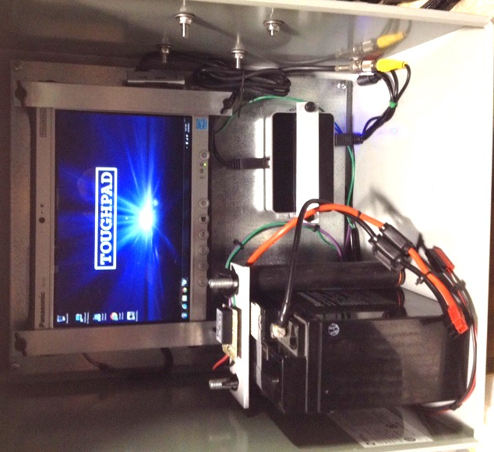
Figure 1. Prototype system used for data collection.
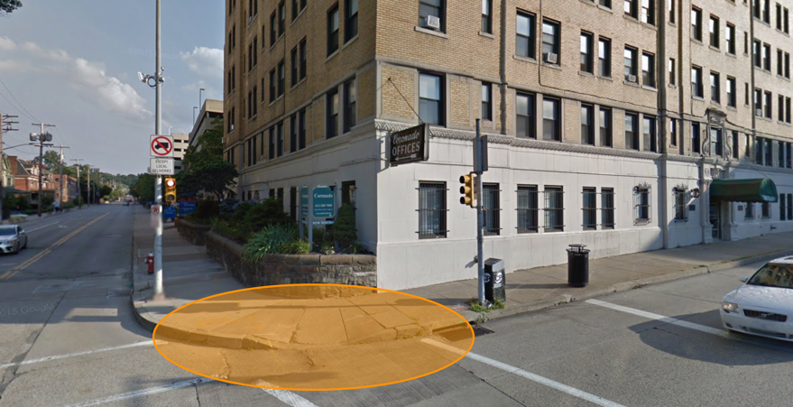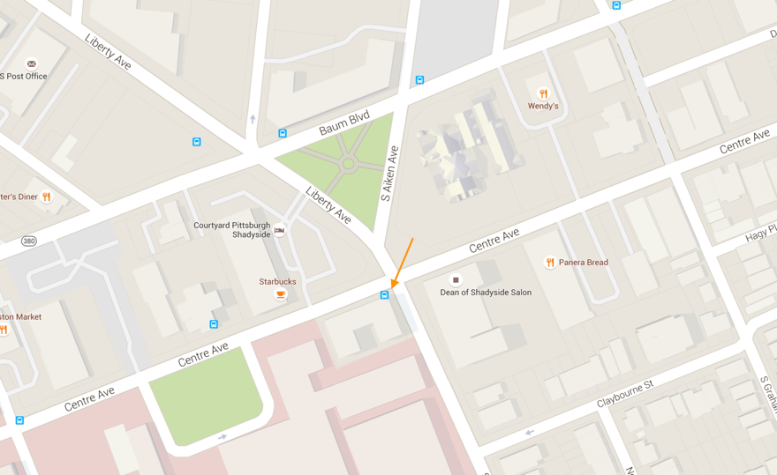
Figure 2. Target location at the corner of Centre Ave and South Aiken Ave.

More than 15 hours of usable data were collected on Wednesdays and Thursdays of two consecutive weeks (Wed, Dec 9; Thu, Dec 10; Wed Dec 16; and Thu Dec 17). For the first week Surtrac was OFF on Wednesday, whereas for the second week Surtrac was OFF on Thursday. For the first week, data was collected from 12:45pm to 5pm. For the second week, data was collected from 12:45pm to 4:15pm. (A third week of data collection was planned, but could not be completed due to construction work on South Aiken Ave.)

Counting and Average Wait Time Results
See Fig. 3 for a sample image of the collected data. The images were processed using computer vision methods to detect and track pedestrians in the sidewalk. In particular, the highlighted regions in Fig. 3 indicate the areas where a crossing pedestrian should travel thru. A pedestrian is counted as crossing the intersection if she appears at the 1 or 2 regions and exits thru the 3 or 4 regions. More than five thousand pedestrians were “seen” by the system. By analyzing the path taken by the pedestrians we determined that 1490 crossed the intersection starting at the selected corner. Table 1 summarizes the results and Fig. 4 details the counts and wait times over 15 minutes’ intervals. To ensure that correct conclusions are drawn from this data, all counts were manually verified.
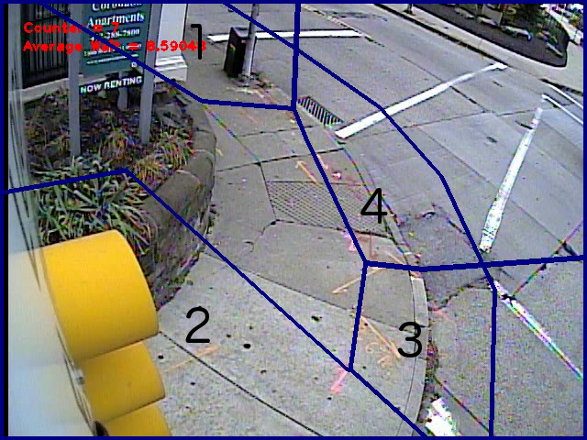
Figure 3. Sample recorded data

 | Week 1 |  | Week 2
Day | Wed Dec. 9 | Thu Dec. 10 | Wed Dec. 16 | Thu Dec 17
Surtrac Status | OFF | ON | ON | OFF
Peds Crossing (total) | 437 | 475 | 303 | 275
Peds Crossing  (per hour) | 102.8 | 111.8 | 86.6 | 78.6
Av. Wait Time (secs) | 16.81 | 18.79 | 17.77 | 15.29
Table 1. Summary of Results.

Analysis of the Results
Overall, we have observed that, average wait times increase when Surtrac was ON. For the first week, the increase is from 16.81s to 18.79s, whereas for the second week the increase was from 15.29s to 17.77s. Further, although the intersection always sees heavy pedestrian traffic, there are significant variations in the number of pedestrians from time to time and, especially from week to week. The average number of pedestrians crossing per hour was above 110 for the first week, whereas in the second week it was below 85. When considering each of the weeks separately, it is interesting to note that the total number of pedestrians is very close, although the distribution of arrivals is significantly different.
In all cases, regardless of whether Surtrac is ON or OFF, the wait times tend to vary very significantly, sometimes approaching the forty-five second mark. This variability in wait times may lead both to jaywalking (as it is well recognized that many pedestrians will jaywalk once the wait time reaches one minute) and to the perception that the situation is worse (as the pedestrian will more likely remember the heavy wait situations than the most common low-wait situations.) In all, it would seem to be a good recommendation to attempt a more uniform distribution of wait times.
Finally, it is important to note that the system cannot detect if the pedestrians jaywalk, which may distort the results. Further, many spurious effects can impact the wait time, including the weather and the proximity to the holiday season. Traffic conditions, accidents of roadwork nearby can all have an effect in the flow of the considered intersection.
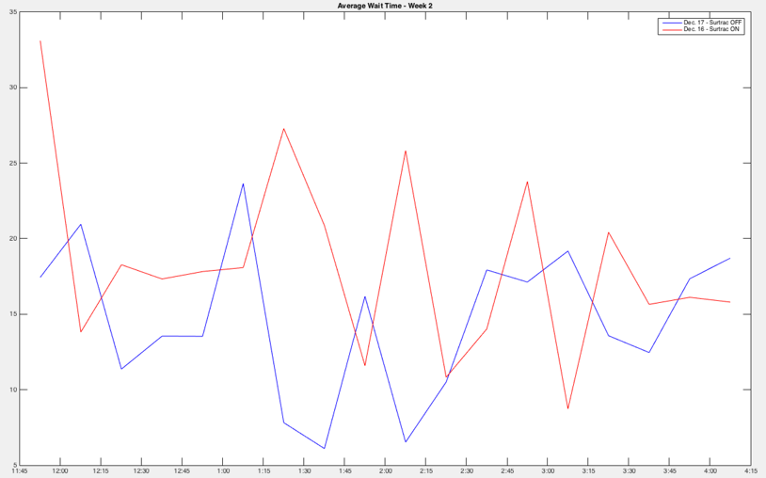
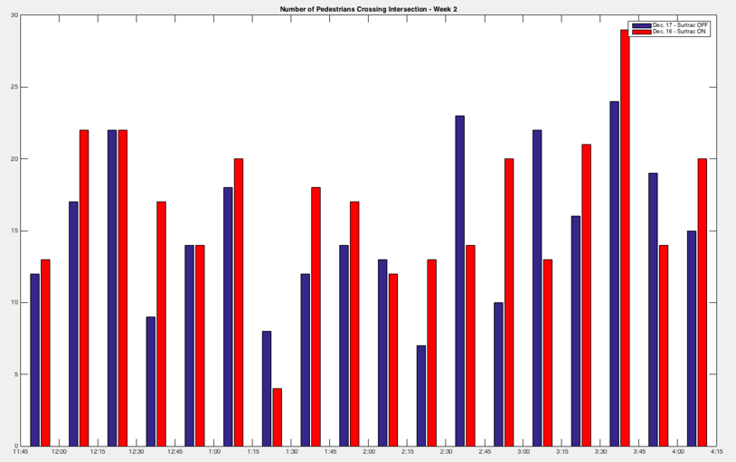
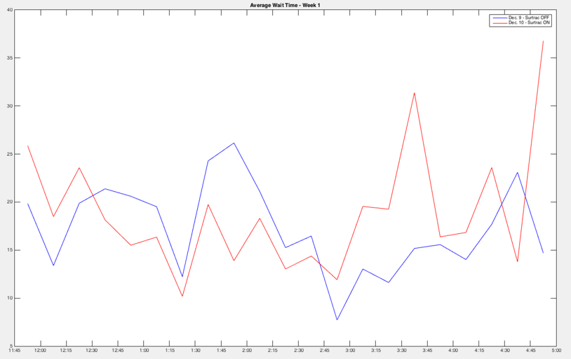
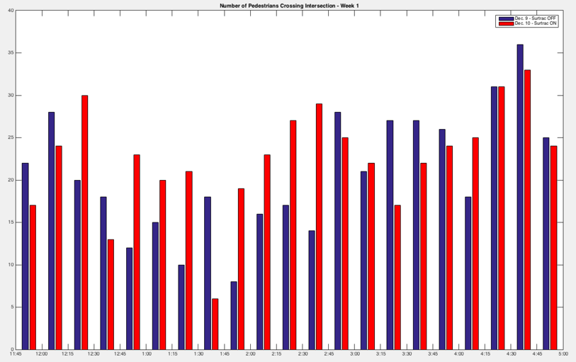
Figure 4. Counting (left) and Average Wait Time (right) results. Top graphs correspond to first week; bottom graphs correspond to second week. Blue corresponds to Surtrac OFF, whereas red corresponds to Surtrac ON.

Future Work
We intend to investigate the wait time question deeper as we move to make one Surtrac intersection “pedestrian-aware” as part of the T-SET funded project “Pedestrian Detection for the Surtrac Adaptive Traffic System”. This project, running thru the calendar year of 2016 and funded by T-SET, will allow us to mount multiple cameras that specifically target the pedestrians and that will be able to record and process data 24/7. Analysis of this data feed will give us much more insight into the effect of Surtrac on the pedestrian wait times.

